**Front Page**

Index

Certificate

Acknowledgment

~~Introduction~~

Java

Data structure

ER Diagram

Content Diagram

Front End and Back End

Tables

Conclusion

Bibliography

**Membership**

**Task of person managing program**

**Problem Description**

**ER Diagram**

**Database Design**

**Project Explorer Code and application snapshot**

**Bibliography**

**Features to add:**

* **Messages are encrypted. Only person who inserted or knows password can view using AES encrypt. Send Official orders**
* **Complete examination mark entry**
* **Chat if possible (Notifications – user and computer generated)**
* **Mini login circular frame and buttons – links to major pages**
* **Library Management**
* **Maths, Physics, Computer and Chemistry lab general Inventory system.**
* **Other non-academic fields such as Electricity, Security, Water, etc.**
* **Sports Department – Events and Winners Record**
* **WAB+ template design**
* **Login Compact**
* 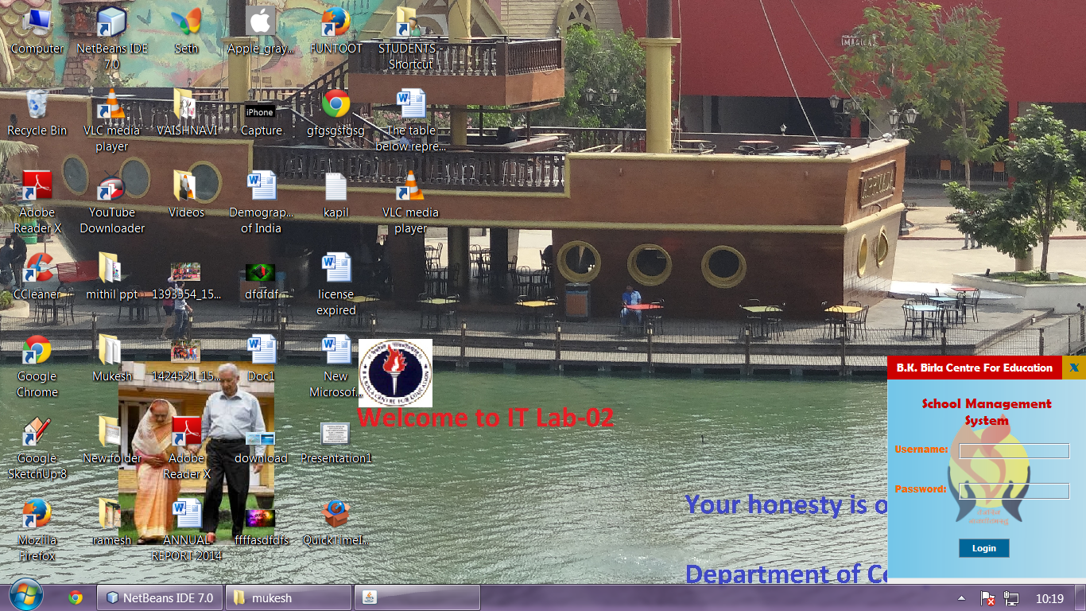

Introduction

Once we have understood the basics of swing java, we are ready to move to newer and bigger challenges. We can now develop full-fledged applications with Swing java. Now, the next question that arises is, “What can be done with Swing Java?” I suggest that it would be more appropriate to ask what cannot be done with it. The answer to the question is: Java can be used to develop virtually anything under the sun. From rapid designing of innovative, user-friendly and dynamic interface with the help of IDEs to synchronizing to databases and other gadgets, Swing java provides the tool that will get the job done right.

Feasibility

The feasibility of our project can be discussed under the following heads:

**1. Technical Feasibility:** Incorporation of latest technology and user friendliness were the foundation principles upon which project was developed. The application has the look (application design) and feel (functionality) of any other modern software of any reputed company in the market. Simple commands and logic have been used throughout the application. The platform independence of java allows it to be accessed on any platform with minimal changes.

**2. Social Feasibility:** The user-friendly GUI (Graphical User Interface) adds to its simplicity of use and makes the system useful even for the layman. The information provided through the application can prove to be really useful to the member of the school.

**3. Economical Feasibility:** The system has been developed using **FREE** and **OPEN SOURCE SOFTWARES** such as Java and MySQL. This saves a lot of money and avoids the cumbersome task of acquiring license for the software. The user can easily access the application by downloading these softwares for free from the internet.

**Analysis and Designs**

**System Description at a glance**

**Shop Management** **System (SMS)** is a dynamic, customised and user-friendly java application that gives the overview of our entire school at a glance. With SMS vital information about the school is just a click away. It adds transparency, accountability and swiftness to the operations of the school. It is a tailored made application designed to meet all vital Scholastic, Non-scholastic and Administrative aspects of the institution **B.K. Birla Centre For Education, Pune**. The bulk of information about the **560 students**, **50 teachers** and numerous other members of the **Birla fraternity** has been made available to the users from the **MYSQL** database through the **Java GUI**. Various relationships among students and teachers in the form of **class teachers, house master and subject teachers** have been ingeniously incorporated into the database through foreign key relationships.

TECHNOLOGY USED

Front End

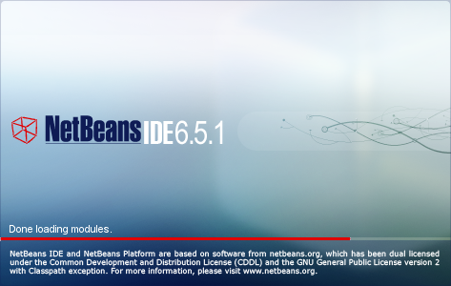

Back End

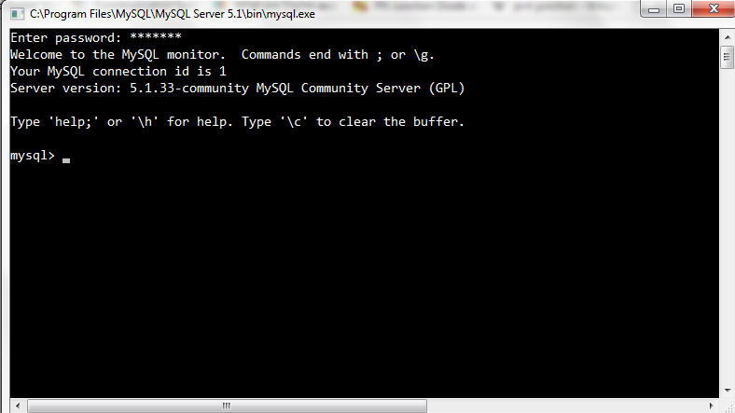

Features of SMS

Much of the data about the school has been made easily accessible to users. Some of the features that users can avail from the **SMS System** are:

* Get a list of items available in the shop. Allows admin/manager to add/delete/modify items.
* Have a look at the inventory and add/delete/update items.
* Make sale by admission number. Each sale once made is attributed to an unique bill no. Make multiple purchases at same time. Dynamic deduction of balance points
* Get a list of purchases made and sort them by admission no or/and bill no or/and date. Displays search record in a table.
* Update Balance Points into students’ account. Reduces the unwanted usage of coupons or money.
* Have a look at the brief reports that are generated by summing up the information in the database.

**Database Design**

The Back end database is housed in the MySQL server. It consists of several carefully designed tables interconnected through foreign keys and triggers.

Some of the important tables that make up the school database are:

Table: **Items**

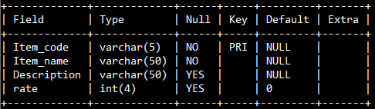

Table: **Inventory**

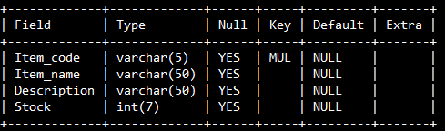

Table: **Sold Items**

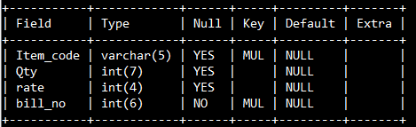

Table: **Bill**

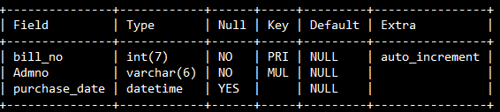

Table: **Student Master**

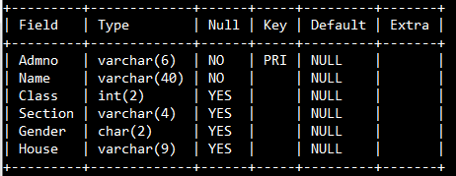

Table: **Login**

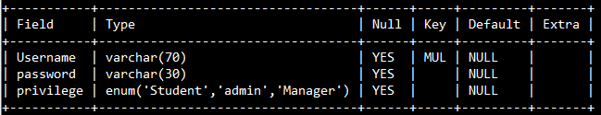

Table: **Login History**

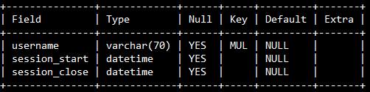

Table: **Balance Point**

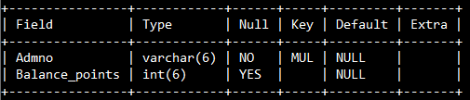

Table: **Admin Point Update**

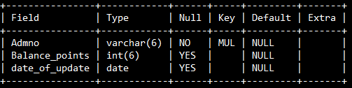

**ITEM SEARCH**

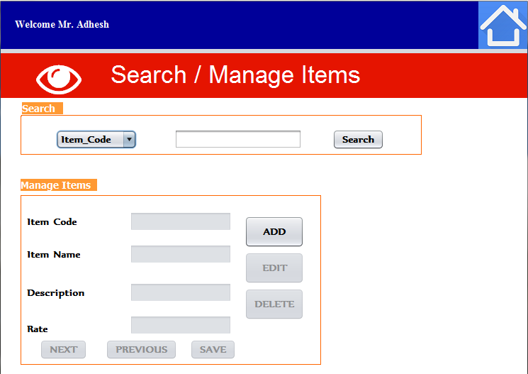

**ITEM SEARCH** provides a detailed profile of the available items. The items can be searched using his item code or name. The search includes all vital information about the item including his description, item code , name and rate. It also offers feature to add new item or edit existing item.

**Windows Opened**

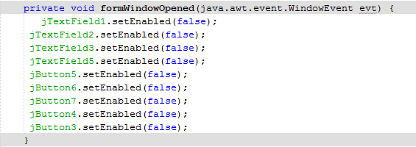

Search Btn Action Performed

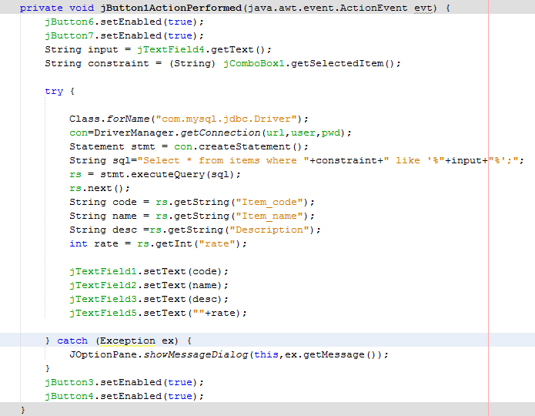

Next Button Action Performed

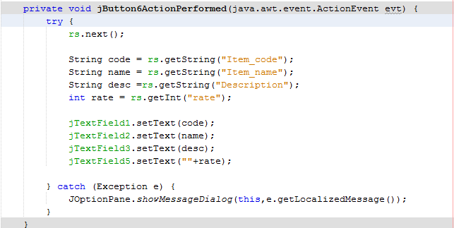

Previous Button Action Performed

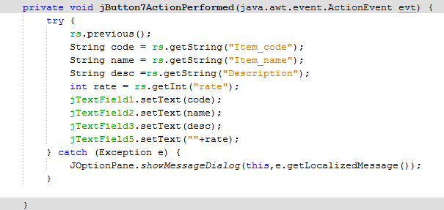

Add Button Action Perfromed

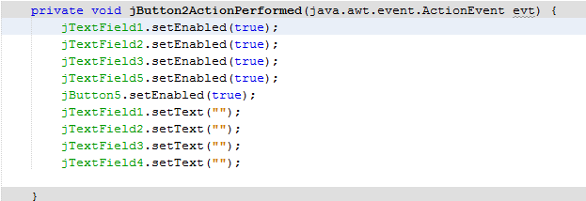

Save Button Action Performed

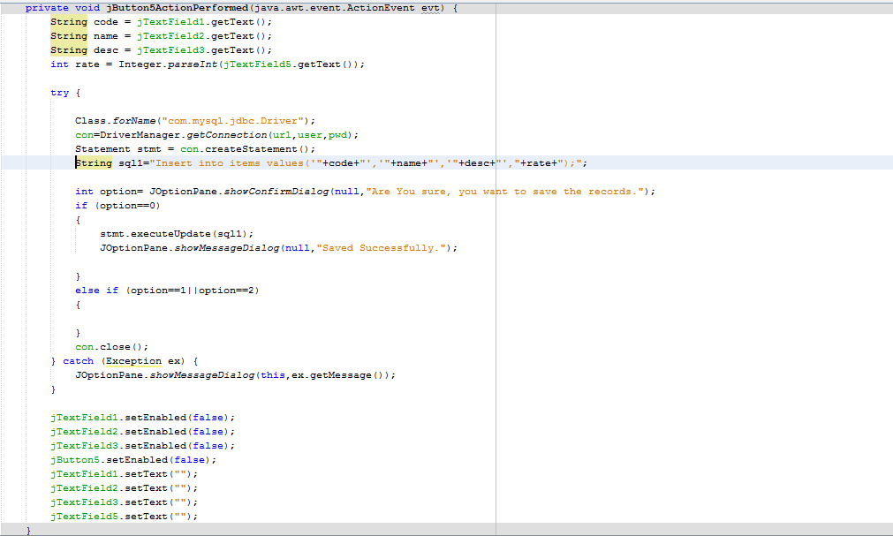

Delete Button Action Performed

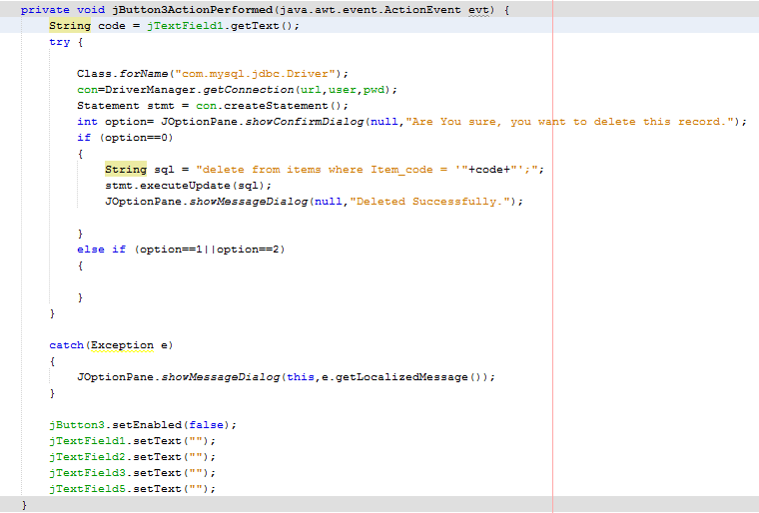

Search TextField Focus Gained

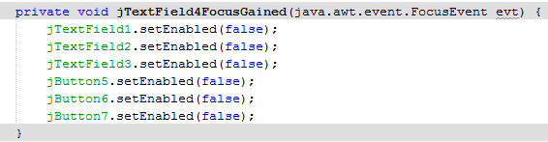

**BILLING**

**BILLING** enables the user to purchase items avialble in the inventory. After entering valid admission number, the user can make his purchase by searching for the desired product. The product is to be then added to the sales table. The balance points get deducted from the balance point field live. The frame also provides feature to delete an item from the sales item.

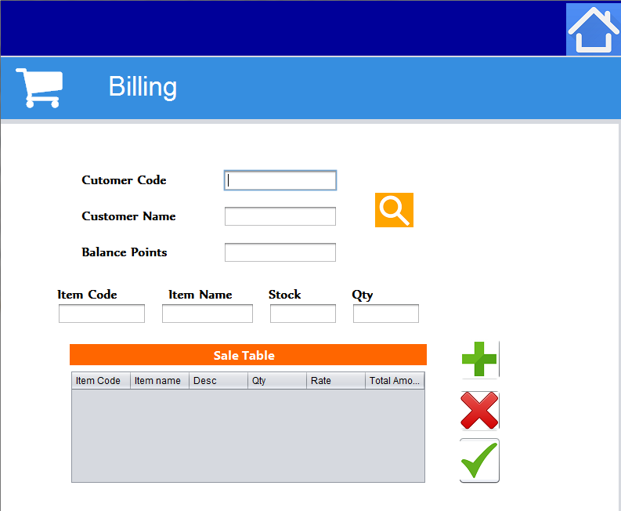

**Search Button Action Performed**

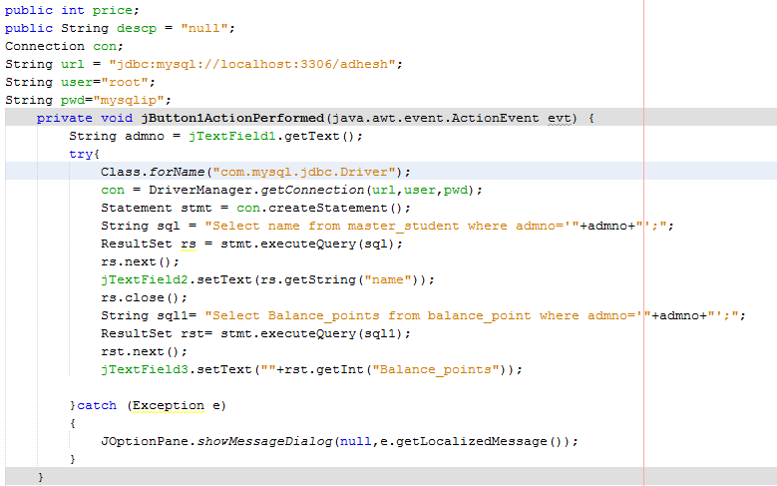

**ADD Button Action Performed**

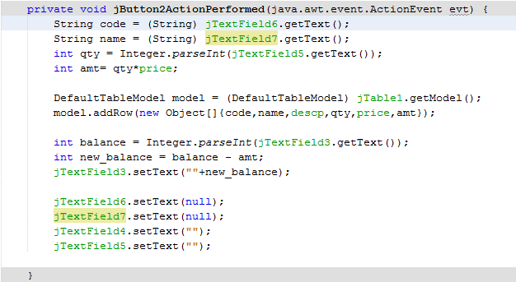

**Item Code TextField Action Performed**

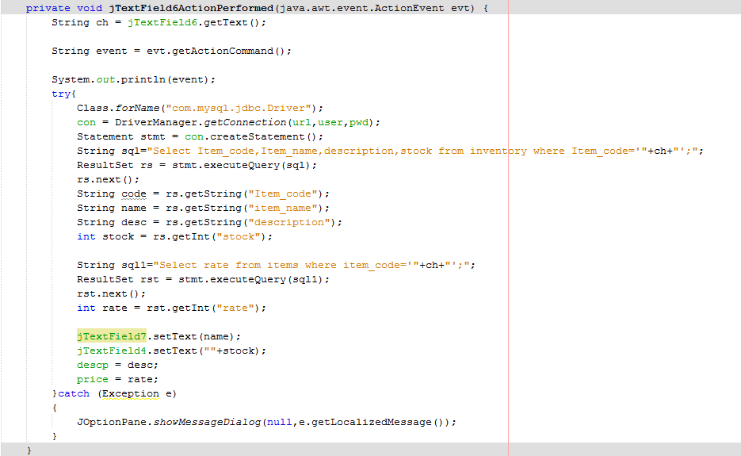

**I**

**DELETE Button Action Performed**

**Item Code TextField Action Performed**

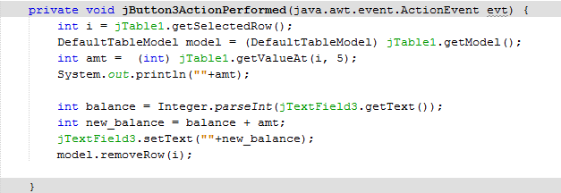

**Item Code TextField Action Performed**

**SELL Button Action Performed**

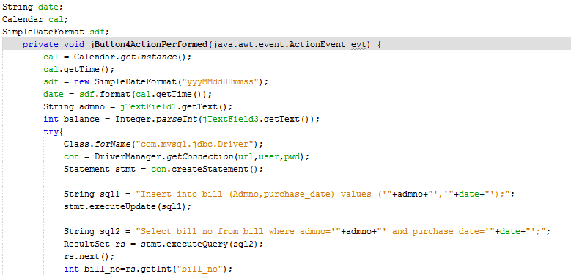 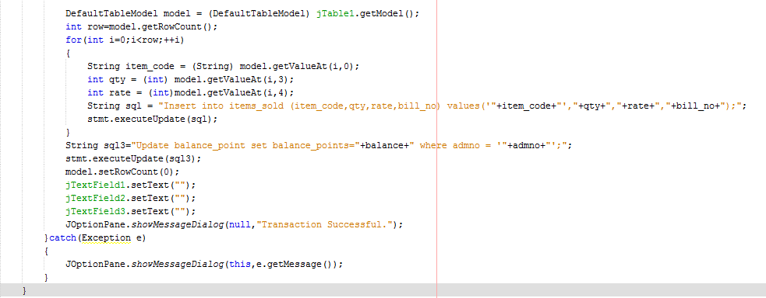

**BALANCE POINT UPDATE**

**BALANCE POINT UPDATE** displays a the update history of an individual student. It also offers the feature to update/add POINTS to the Student’s account.

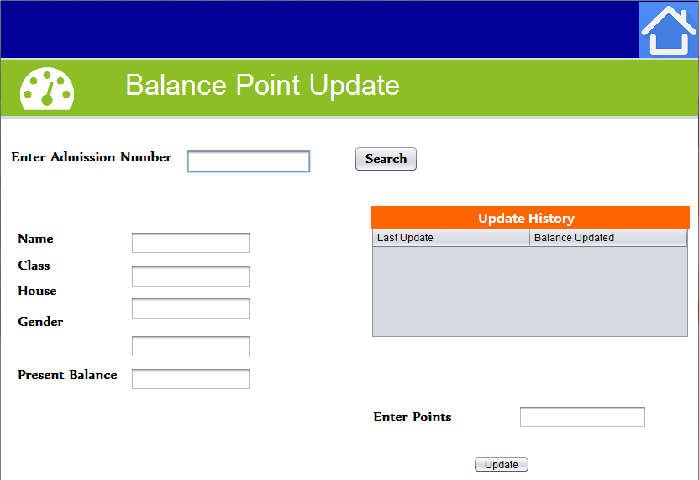

Windows Opened Action Performed

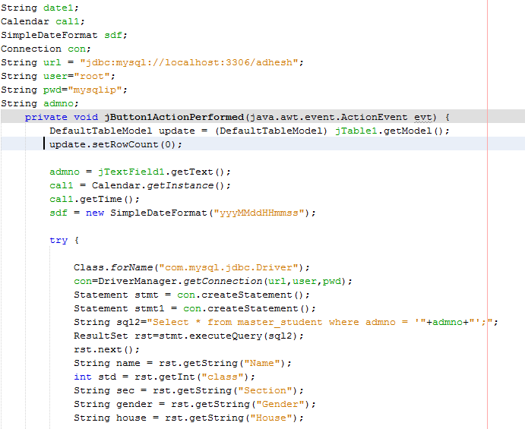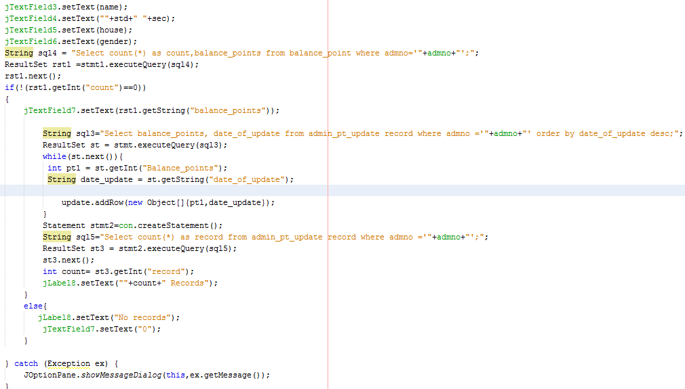

**Update Button Action Performed**

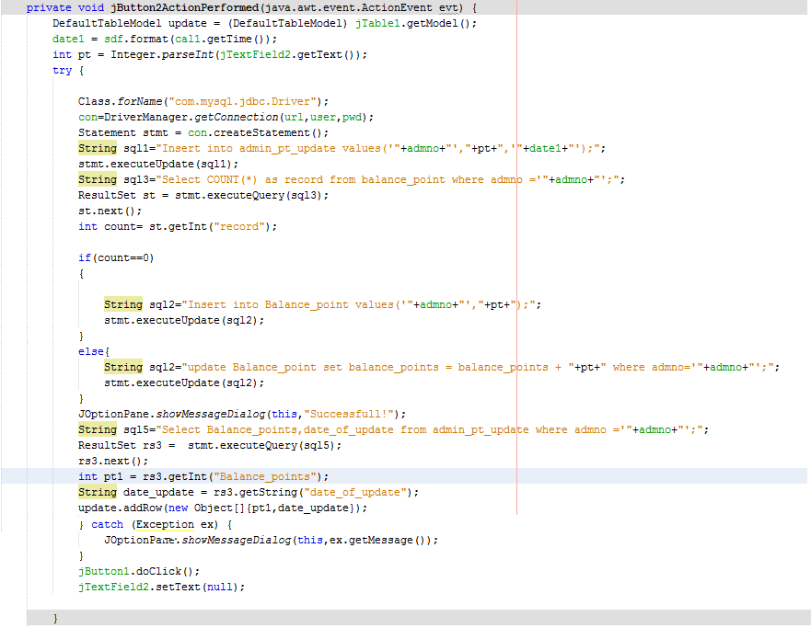

**FILTER SALES**

**FILTER STUDENTS** gives a list of sales which satisfy the search conditions imposed by the user.

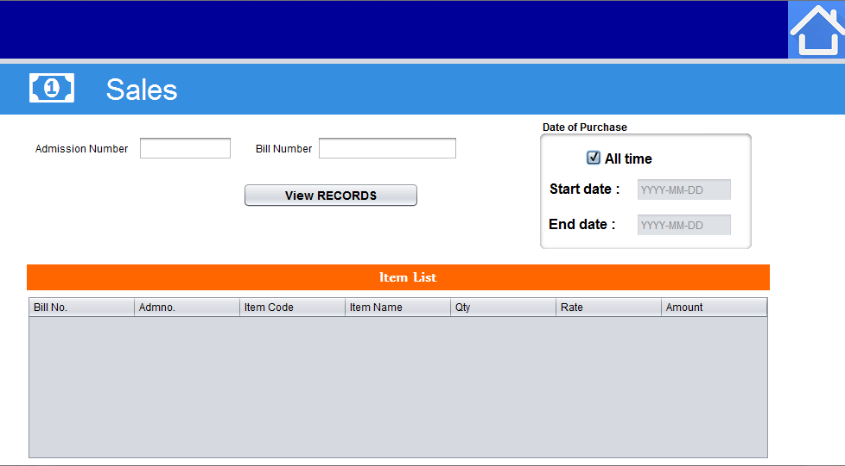

**Date** **CheckBox Action Performed**

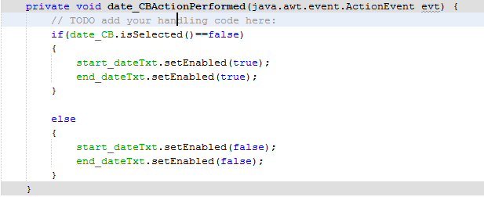

Search Button Action Performed

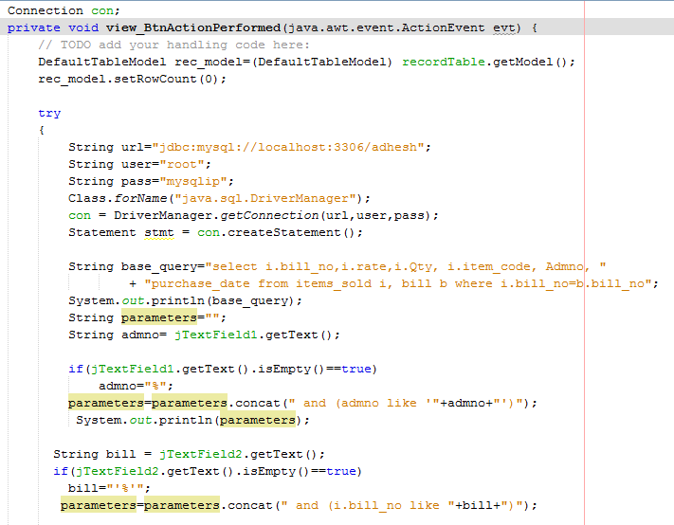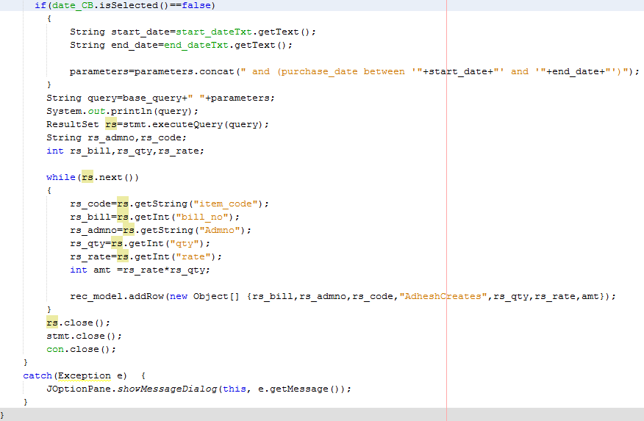

**INVENTORY**

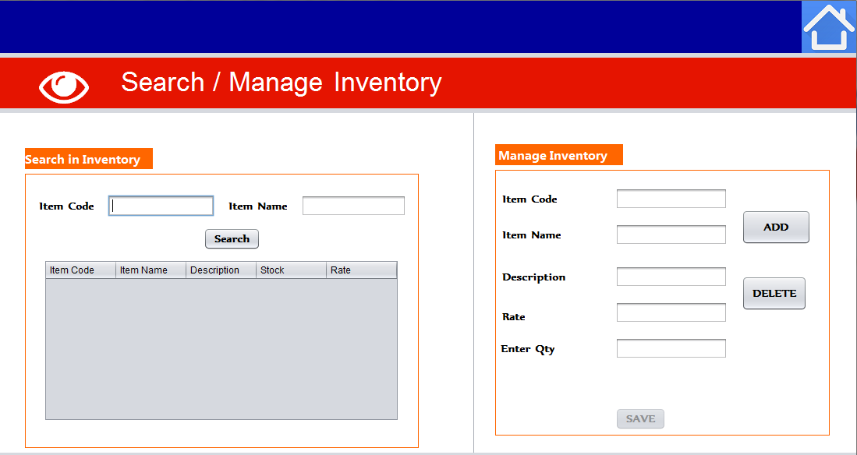

**INVENTORY** provides information about the quantity of items present. It also allows user to add/delete/update stock.

**SEARCH Button Action Performed**

**ADD Button Action Performed**

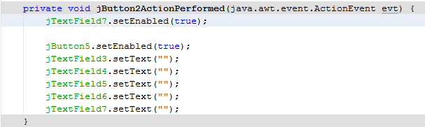

**SEARCH Button Action Performed**

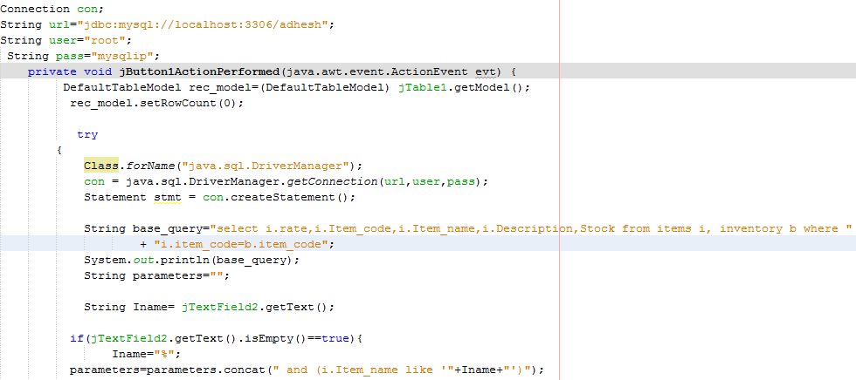

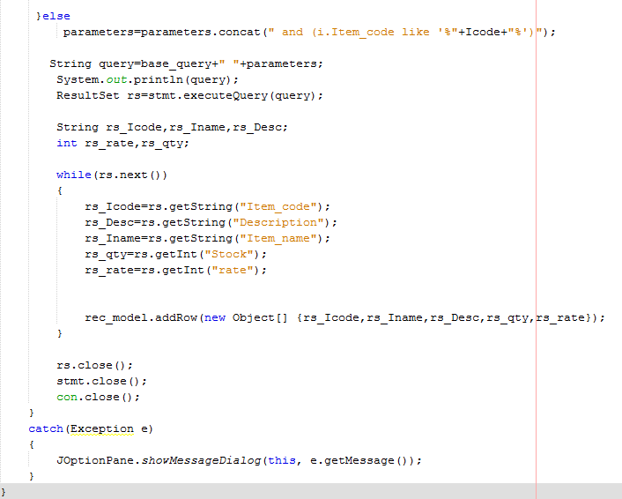

**SEARCH Button Action Performed**

**SAVE Button Action Performed**

**SAVE**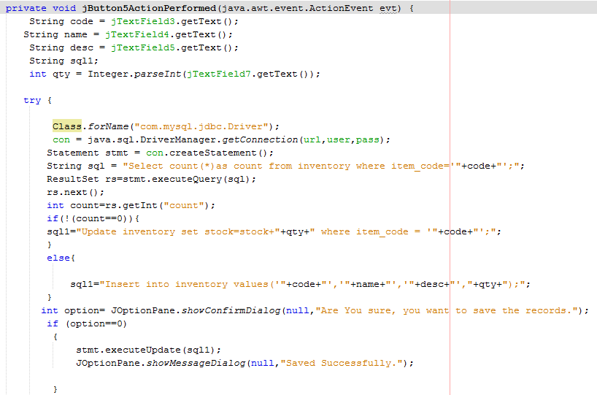

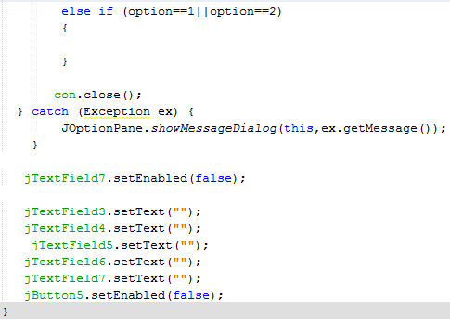

**LOGIN HISTORY**

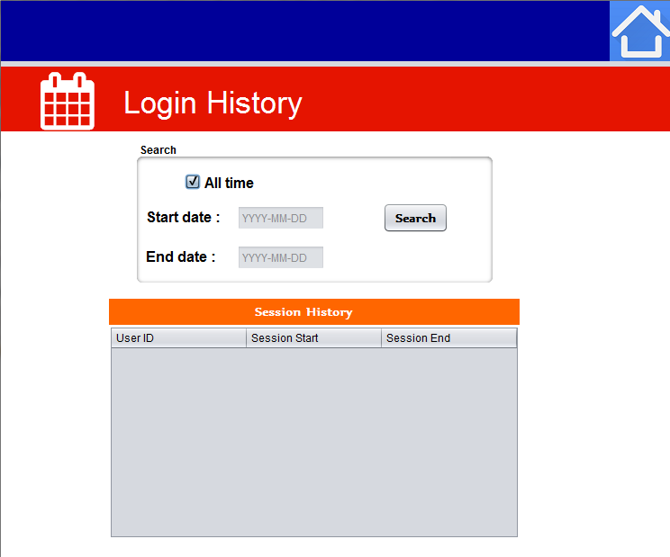

**LOGIN HISTORY** provides an overview on the session history. It displays the list of admins/managers who had accessed the software along with the date and time of session login and logout. It also offers feature to search records by date.

**Date Checkbox Action Performed**

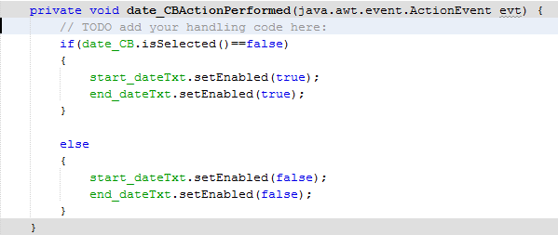

**Start Date TextField Focus Gained**

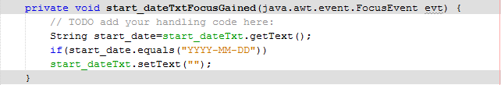

**End Date TextField Focus Gained**

**Start Date TextField Focus Gained**

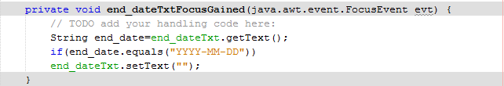

**Start Date TextField Focus Gained**

**Search Button Action Performed**

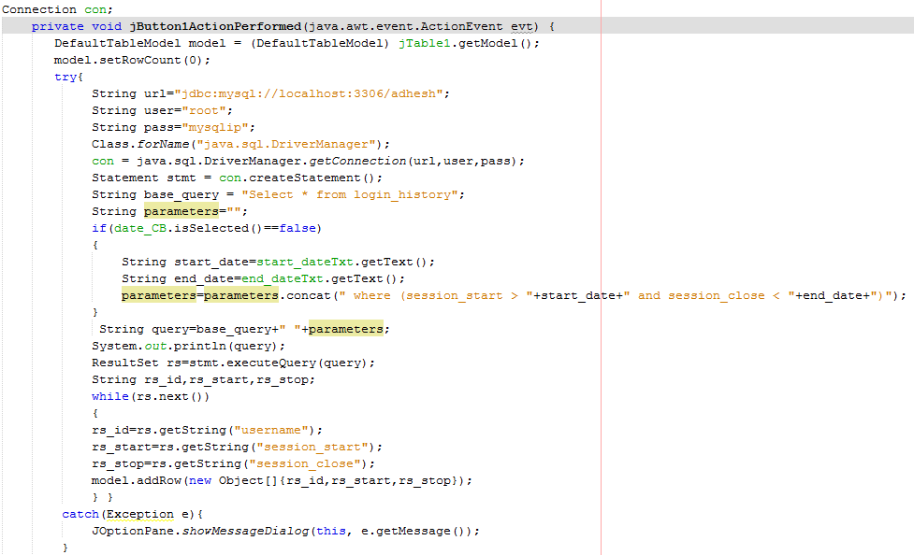

**DASHBOARD**

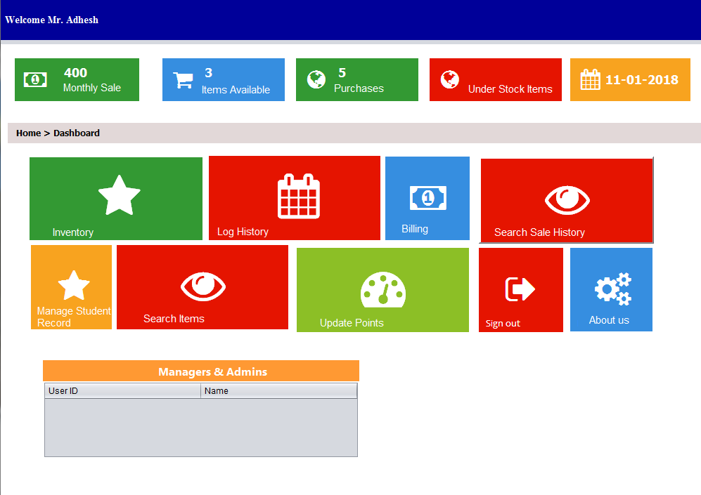

**Start Date TextField Focus Gained**

**Form Window Opened**

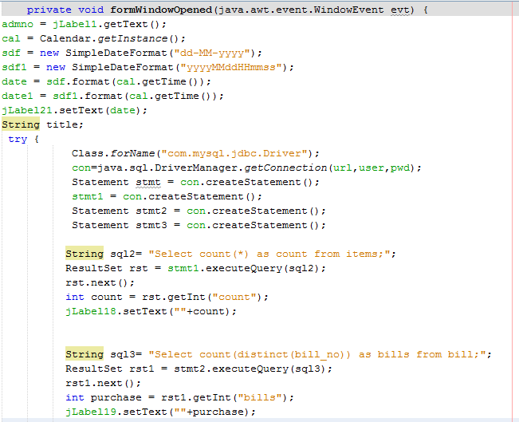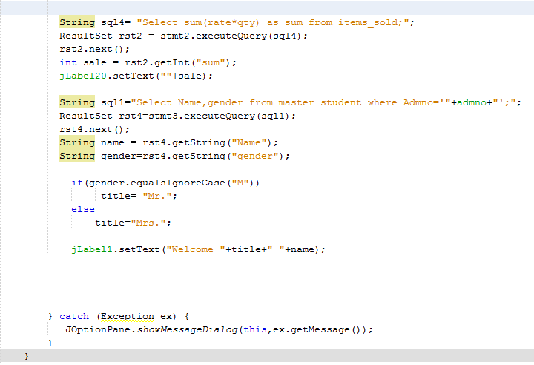

**Start Date TextField Focus Gained**

**Mouse Entered/Exited Events**

**/.. This event has been repeated for all the labels which were connected to another frame and worked as a button. ../**

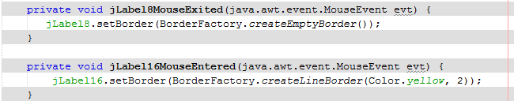

**Mouse Released Events**

**Start Date TextField Focus Gained**

**/.. This event has been repeated for all the labels which were connected to another frame and worked as a button. ../**

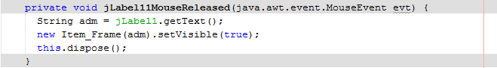

**Released**

**Form Window Closing Event**

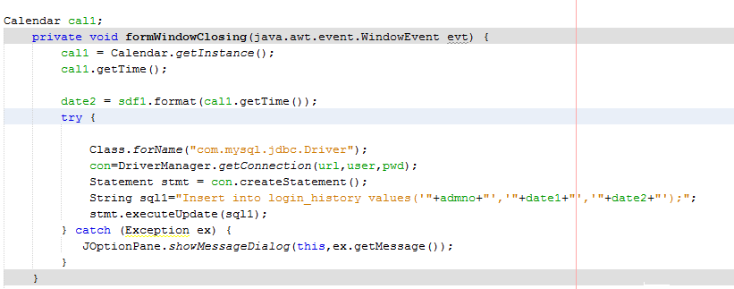

Future Prospects

The “Shop Management System” was our first step into vast mystical and mind blowing world of programming and application designing. We are at times lost in its depths because of the myriad kinds of avenues and possibilities that perfect harmony of Java and MySQL opened for us.

We left no stone unturned to make the application user-friendly and more dynamic. However, keeping in mind the constraints of time and resources, we were forced to limit the features and functionalities of our project and bring it to an abrupt end.

We have many unimplemented plans for our projects that can make it more robust and dynamic. Some of which include:

* To centralise all operations of the school and add to their transparency, speed and accountability. Some areas of importance including sports, library, store, labs and electricity.
* Creating applications to enter marks and to graphically analyse the student’s academic progress.
* To design an inventory for the school labs.
* We would like to port our stand-alone application on web-based platform and make it accessible to maximum end users.
* We would like to enhance its accessibility by using interactive voice system.

We are hoping to bring more useful changes and implementing our ideas on this project in the days t o come.